1.4 I can carry out appropriate checks on others' online identities and different types of information

On certain sites like Facebook and Twitter people can often use Alias names or try to impersonate celebrities or companies, one of those examples is:

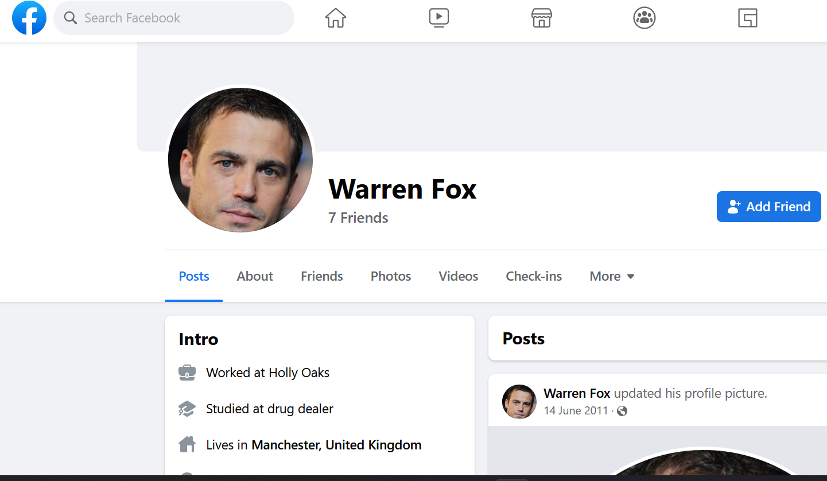

[The above photo shows a Facebook profile of someone impersonating a character from a TV show called Hollyoaks]

While this is an innocent take on impersonating someone, it still could cause confusion.

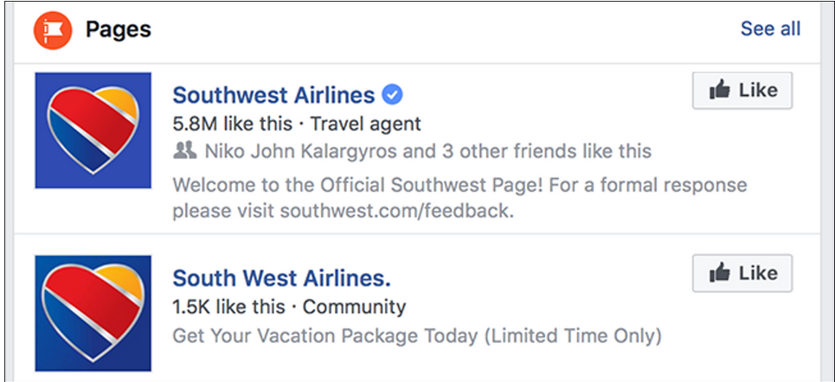

[The above photo shows two profile pages on Facebook, one is of the real Southwest Airlines company page (you can tell because of the verification tick and the description underneath tells people visiting the page to get help from their company website) and the other is a fake page impersonating them (you can tell because there’s no verification tick and the description is telling people to click on a link to get a limited time deal)]

If people didn’t know about the verification tick then they would believe the page impersonating the company is real and might fall for the scam.



[The above photo shows an advert showed on Facebook of Martin Lewis and underneath it tells people they can invest money into a new scheme that the link will take you to. It will then continue to scam the person who clicks on that link and possibly take their money]

One way to spot that it is a fake advert is that the page will sometime have different fonts for their page and the quality of the photo attached to the advert will be of bad quality. You should always search for the celebrities name and see if the have published the advert or news article on a reputable site such as their official website or their social media pages.

Gossip sites and news publishers post fake news articles, this usually happens when the news writers don’t fact check their articles, this is an example:

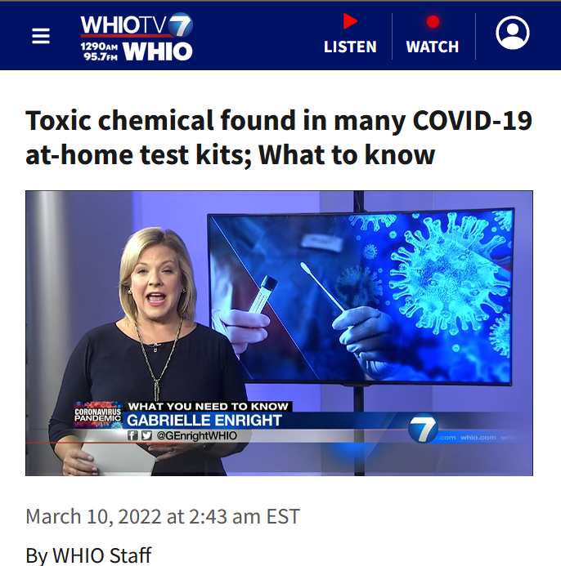

[The above image shows a news article from WHIO in America and a headline that reads ‘Toxic chemical found in many Covid-19-at-home test kits; What to know]

This article is misleading because the information about the Covid-19 tests aren’t true as this states:

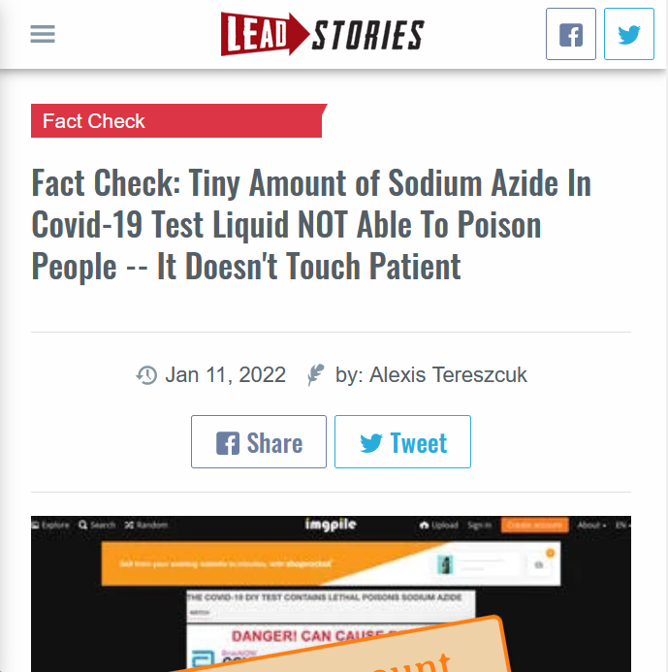

[The above image shows a news article about the Covid-19-at-home-tests and how the sodium azide isn’t poisonous to people using them]

These sort of news articles are good because it allows people the proper information that they heard from other news sources which were false.